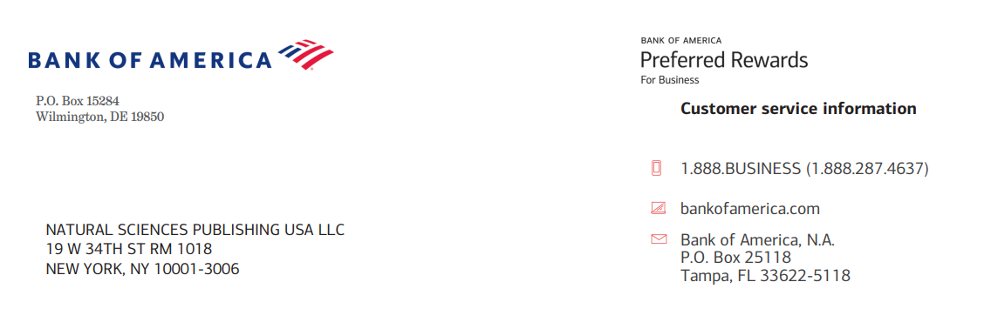

Statistical analysis of the impact of integrating students with special educational needs on their regular peers within the educational environment
27 July 2026

https://www.naturalspublishing.com/

Name of Journal:

Bill To:
Department of Mathematics and Sciences, Prince Sultan University, Riyadh 11586, Saudi Arabia Email: sjohani@psu.edu.sa

Title: A Comparative Statistical Study of Time Series and Deep Learning Models for Short-Term Stock Price Forecasting.
Ref. 07222601A
Email: datascienceactuarial03@gmail.com
Author(s): Sawsan Kara, Nadia Ghalia, Mawaheb kheir Mustafa, HIYAM ABU REYA, Darawsheh Ahlam, 1 An educator Ministry of Education, Dalyat El Karmel, Israel, 3 An educator Ministry of Education, 4 An educator Ministry of Education and Sakhnin

Ref. 07222601A  22 July 2026 | Sawsan Kara  Discount $ 600.00  Total Charge $1500.00

For payment, please use Bank transfer to:
Beneficiary Name | Natural Sciences Publishing USA
Bank Name | Bank of America
Bank Branch | 1293 Broadway, NYS-149-01-01, New York, 10001
NSP Address | 19 W 34th St. RM 1018, New York, NY 10001-3006
SWIFT Code | BOFAUS3N
Account Number | 483052729147
Wire routing number | 026009593
E-mail | nsp@naturalspublishing.com
Telephone | +1 (646)556-1606
